*Chromobacterium*

Family *Vibrionaceae*

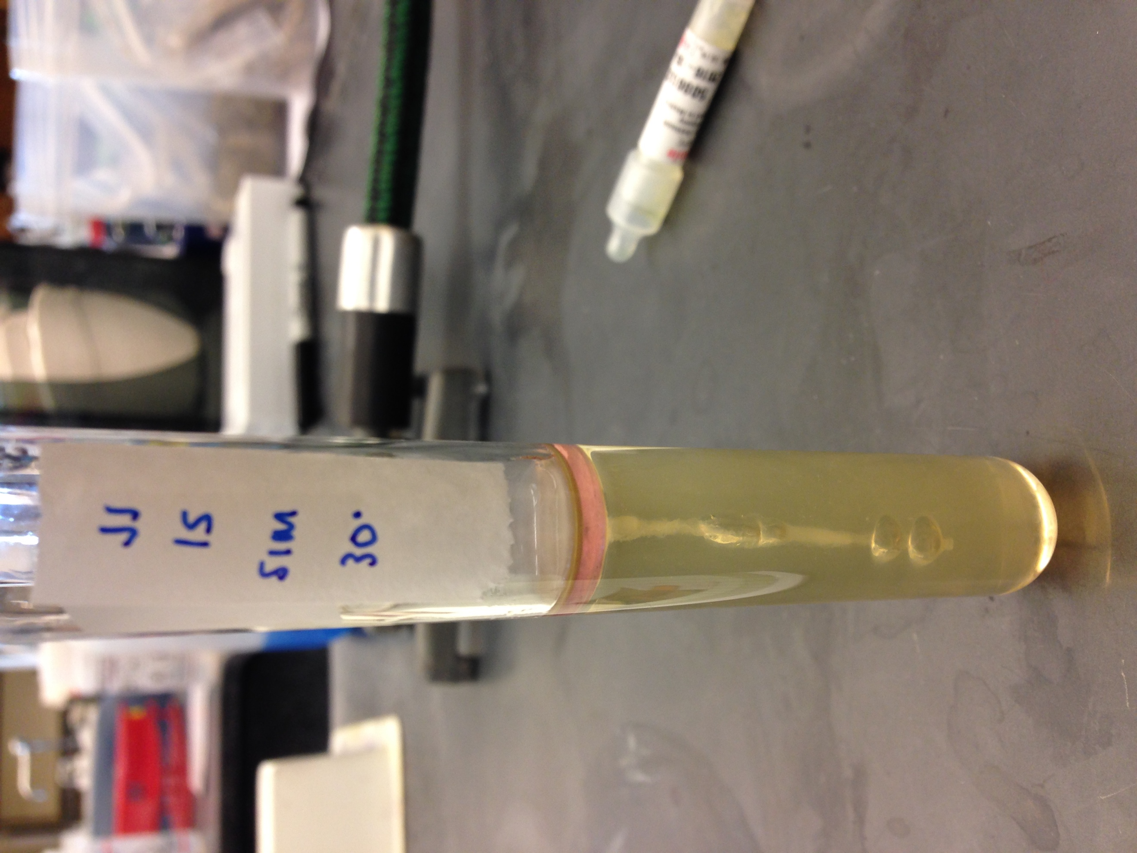

*Cardiobacterium*

*Gardnerella*

*Eikenella*

*Streptobacillus*

*Zymomonas*

*Calmmatobacterium*

Family *Enterobacteriaceae*

Family *Pasteurellaceae*

*Cedeceae*

*Enterobacter*

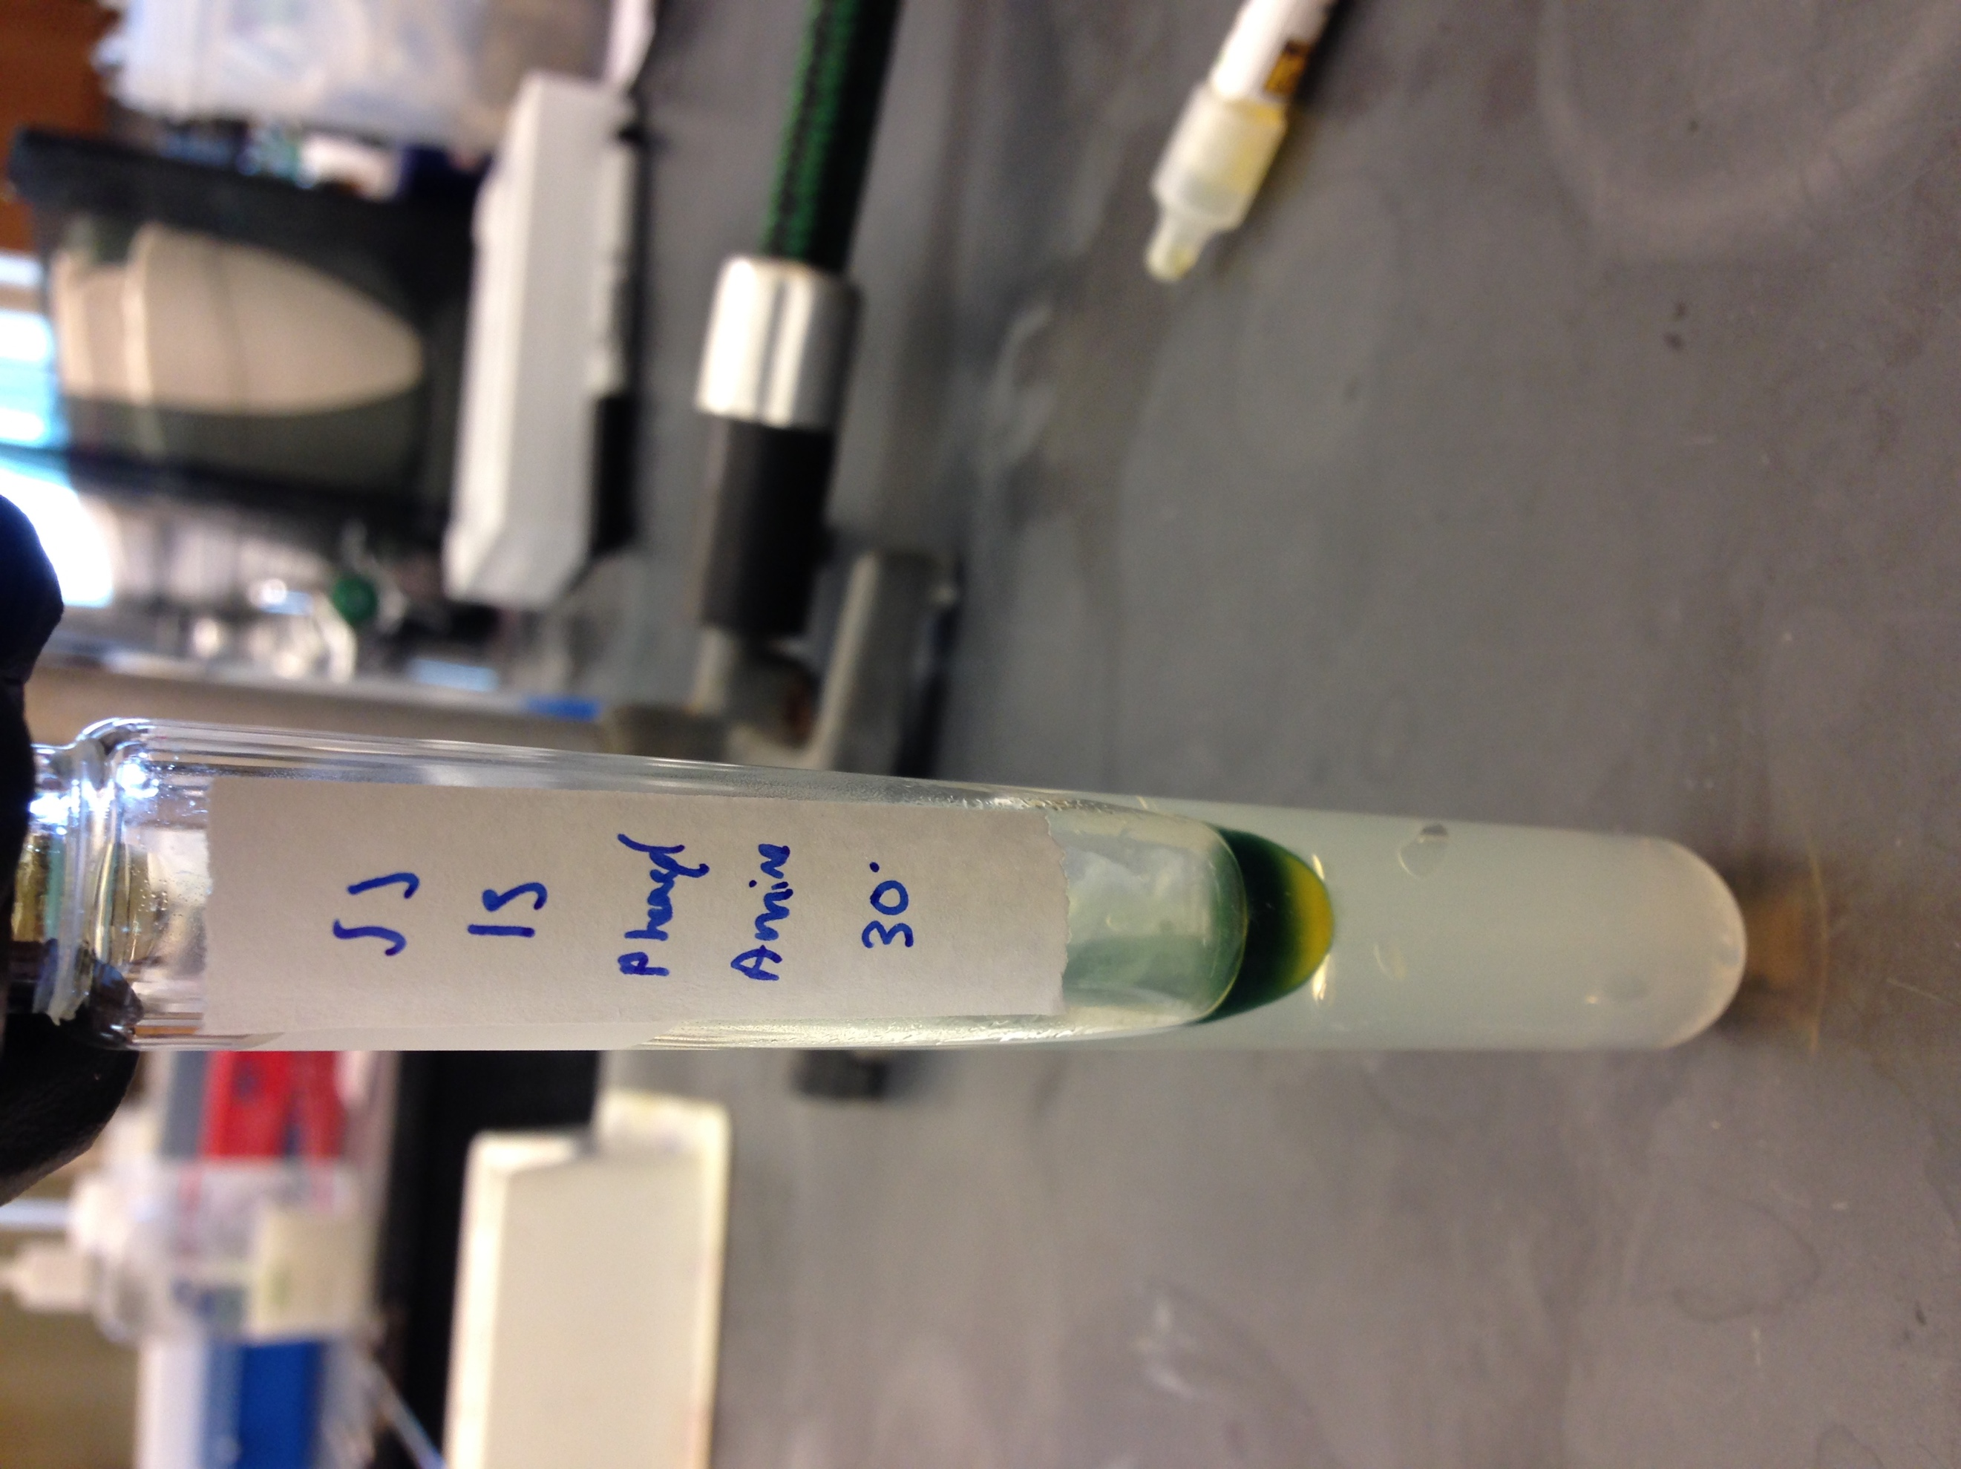*Erwinia*

*Pantoea*

*Proteus*

*Salmonella*

*Xenorhabdus*

*Klebsiella*

*Liminorella*

*Shigella*

*Yersinia*

*R. aquatilis*

*S. plymuthica*

*P. heimbachaea*

*E. coli* (inactive)

Lipid Hydrolysis

Indole Production

Phenylalanine Deaminase

Nitrate Reduction

Methyl Red